# Logging in to Kringlecon2

First, go to <https://2019.kringlecon.com/invite>, and click the big red logo in the center.

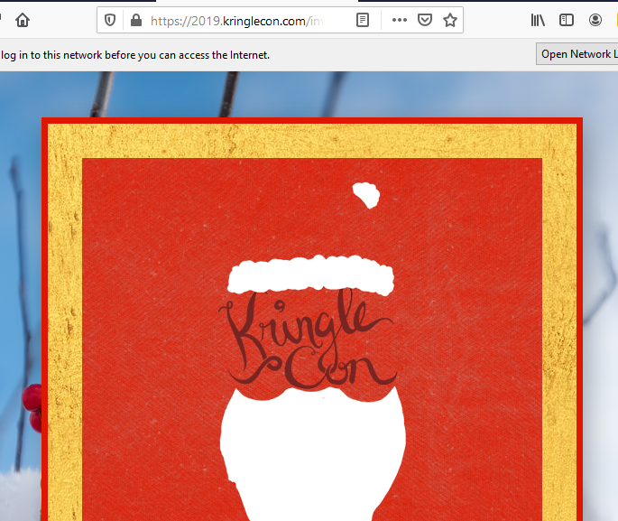

Create an account. Don’t worry about limited space.  
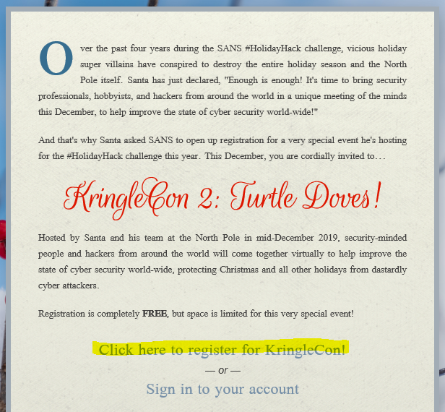

Fill out the form. Don’t use a password that you use anywhere else. For game you can use a throw away password like password.  
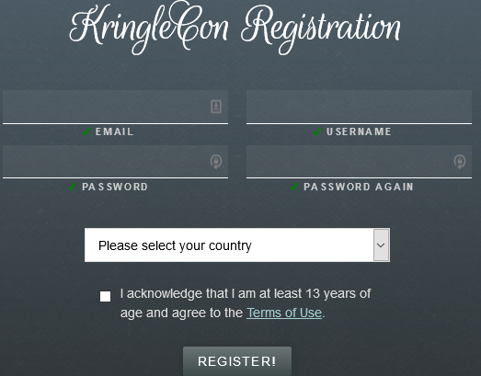

Then sign into your new account.  
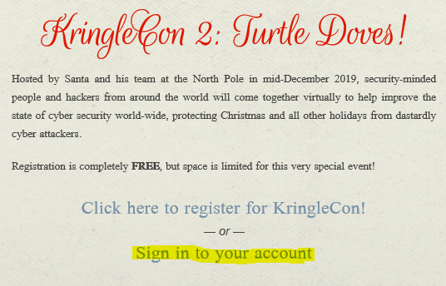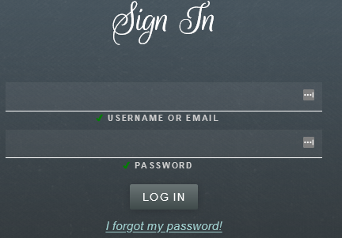

You’ll start at the train station next to Santa. Head north, to the top of the screen. You can click or use arrow keys to move.  
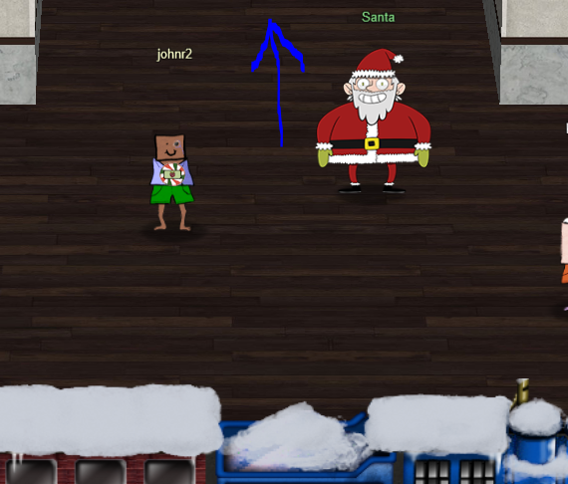

Head left and up to go to Hermey Hall.  
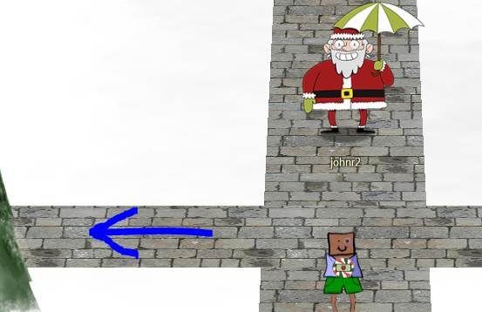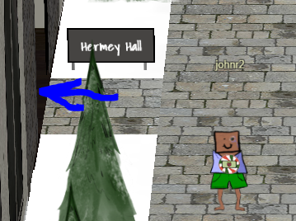

Once you are in Hermey Hall, go all the way to the left and enter the Laboratory.  
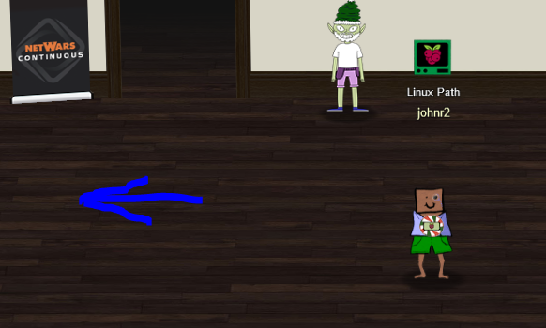 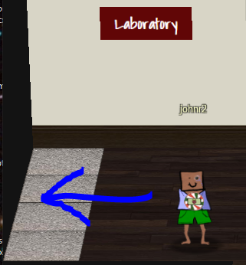

Click on the computer, Xmas Cheer Laser, and get started. If you like, you can click on Sparkle Raspberry to see what he has to say.  
